Java Chat Messenger

The User guide



Submitted by: Nassim Zaher

Java Course – Telhi Collage.

Submitted to: Eyal Shifroni.

I will explain how to use and about development of the three parts
- Client interface.
- Main Server interface.
- Data Base Server interface.

There is 3 application the first one is the client that will be in the user side , he can log on to the system or add a new user to the system , but this application connect over the internet with the encryption mode to the Main Server side and request what's he need ,by example "add new user" or " log on with my user " … then the Main Server connect with the Data Base server with encryption mode too, to work with the Data Base…

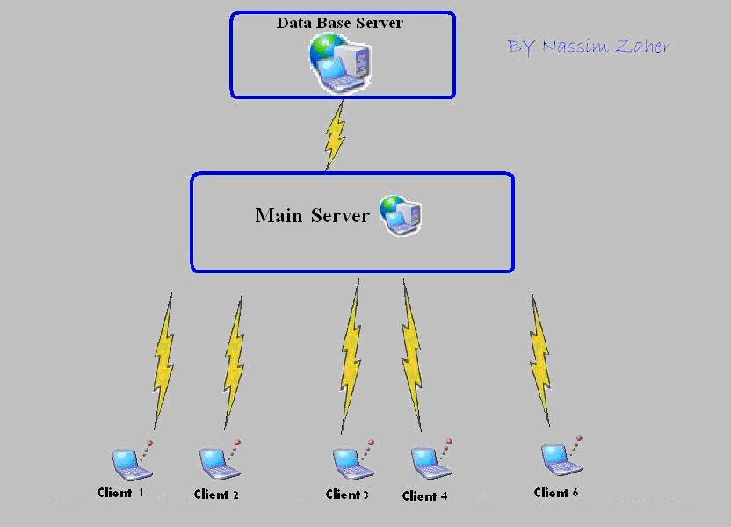

Client Side:
The user first of all must logon or add a new user
Logon:
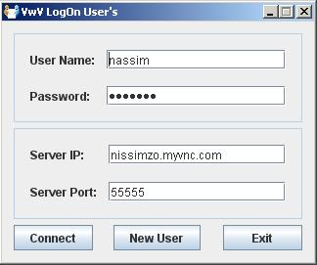
Here you must type
the username and the
Password if exist.
Here you must type
the server IP and
Port to connect.
Then must press connect
For Register new User click here

Add New User:
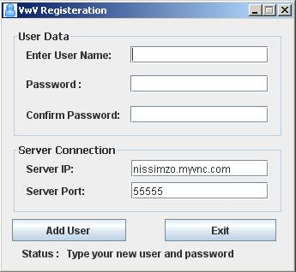
Here you must type
the server IP and
Port to connect.
Here you must type
the username and the
Password if to add it.

Then must press Add User

Then after the logon or the adding new user will open the main window automatically
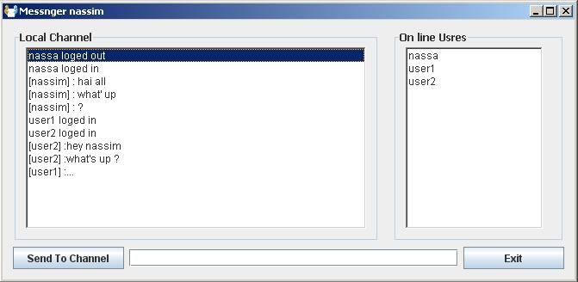
Here if the global chat window for all of the users you can see all the users global msg. it's mean that all of the users can talk with us here.
Here type your message…. and press Send To Channel.
Here you can see the online users

Then you can choose any user from the online users list and can open with him a private chat:

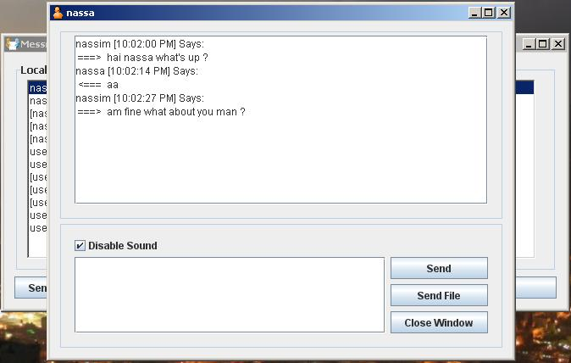
You can send to the this user a file by clicking here

With installing you must put at C:\VwV\sounds for all the sounds
And the same thing for the icons C:\VwV\icons

Sending File:
After you will choose the file name and location for sending will start the sending automatically and you see 3 important things for finishing sending...
  - percentage
  - progress bar
  - send data by KB
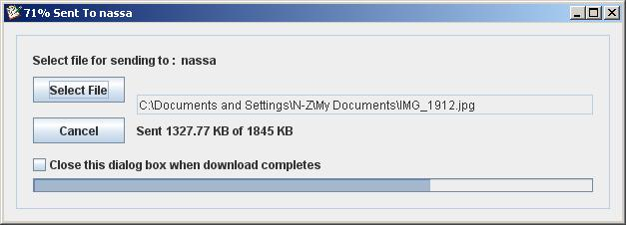

What about the other side when receive a file?!?
Will see this …

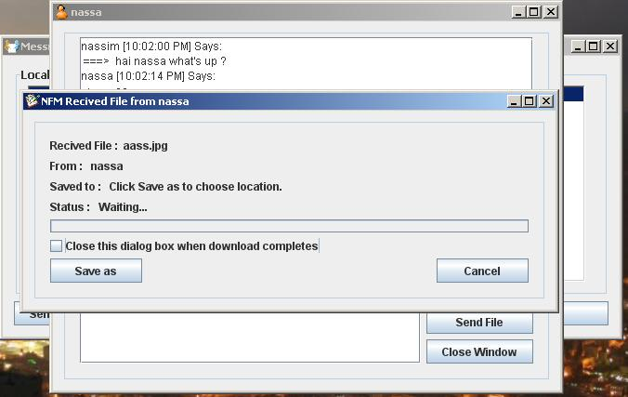

After accept and choosing location for saving file:
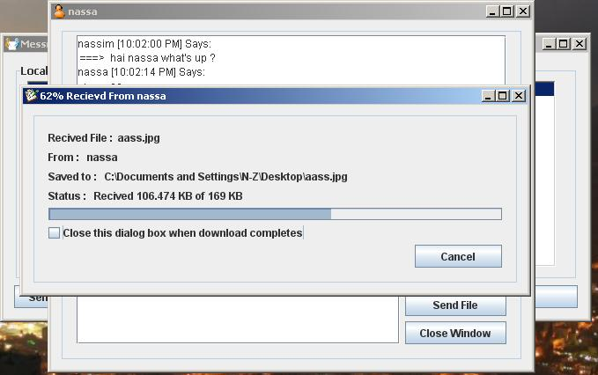

What about if 2 or more users logged on from the same computer? Most of the programs that we know!! Like msn messenger or skype … it's doesn’t accept for you to connect from the same computer … cause the 2 or more application will use the same port to get a files But my application yes accepts it and you will receive files.

Main Server:
This is the main server that all of the users connect to the it and this application connect to the Data Base server for working with data base
The main window :
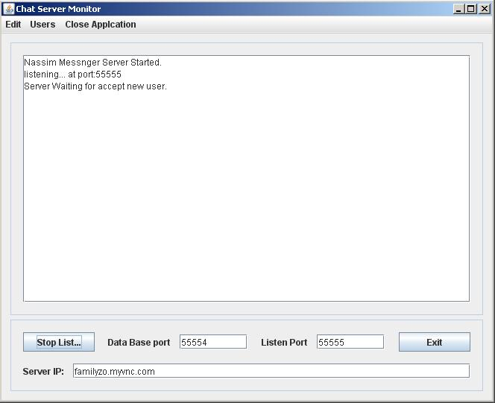
Data Base server IP and Port
The listen port for accepting new clients
Press here for starting and stopping the listen mode

Some functions in the Main Server from the clients:
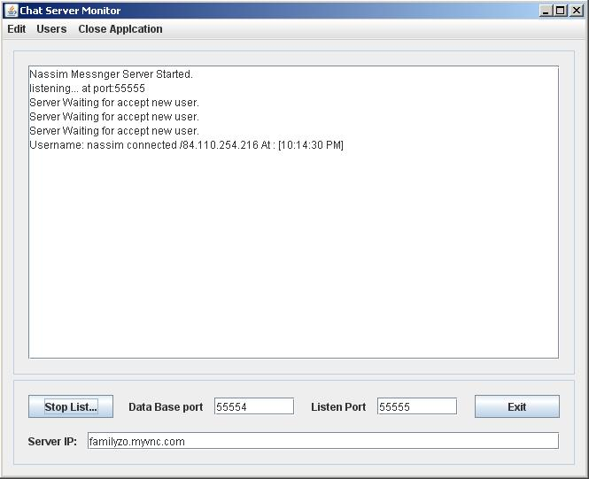
We can see all of the users in the database: by clicking Users - > List of Users
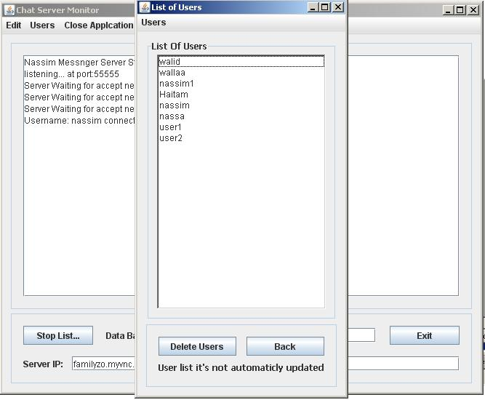

And we can delete any user we want to:
By selecting the user and pressing on the delete users button
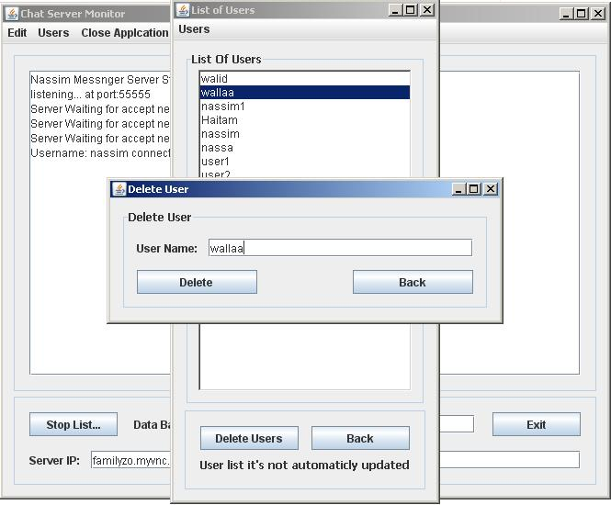
Data Base Server:
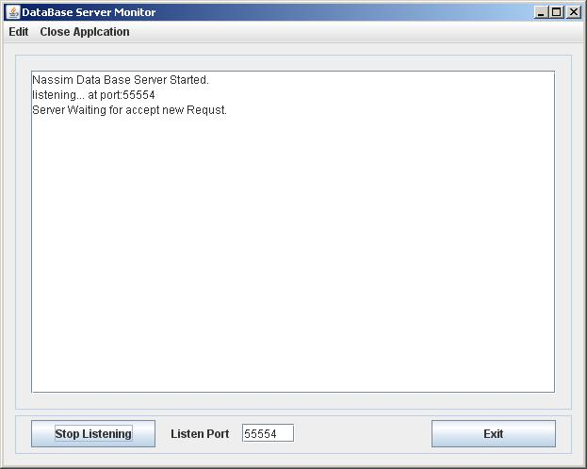
See some requested function on the database server:
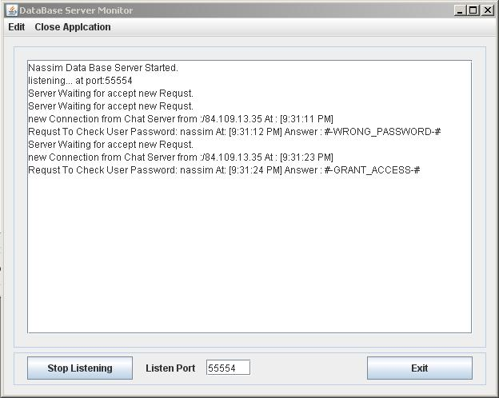
This user name tried to connect with a wrong password.
This user name tried to connect with a password and accepted.
How to connect the driver of the database…..
Go to “control panel -> Administrative tools - > Data Sources (ODBC)
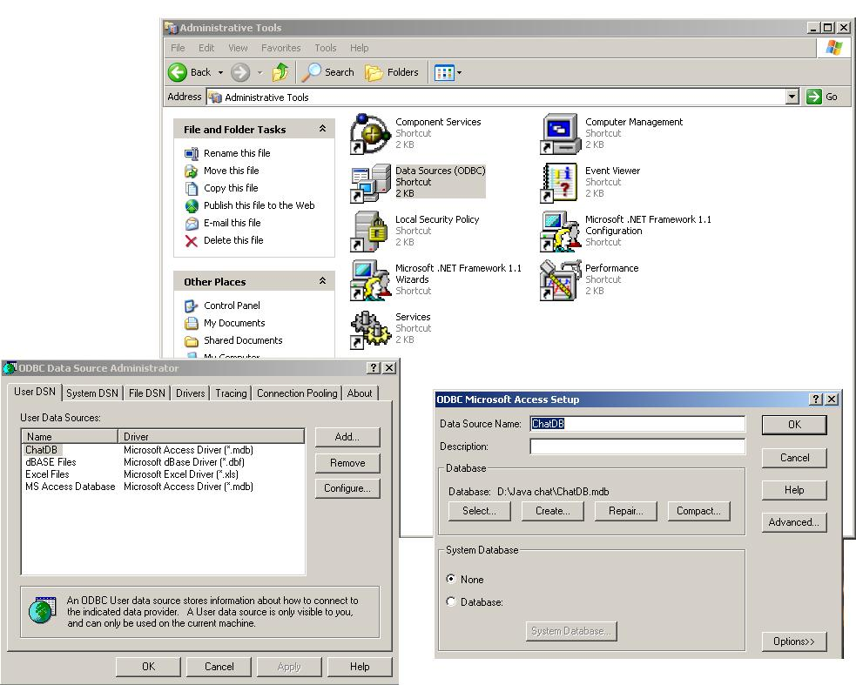



This is chat software that developed in a Java Language at the Java Course of TelHai Collage.

What we use in our project:
- the java language developed in the Netbeans of sun
- The java syntax: control statements, methods, arrays
- classes, inheritance, polymorphism, Interfaces
- Exception handling
- Strings, characters and regular expressions
- events
- GUI concepts
- Multithreading
- Files and Streams
- Databases
- Networking, Stream sockets
- Encryption & Decryption

- All of the connection is encrypted with the Des algorithm First of all we generate the key then we send it to the other side ,the other side build the new key and starting the connection with the current encryption , there is a class that do all of this things.

Look for these before you start reading the Developer Guide.
What the sender send :
«Reciver name ----- untill 30 chars ----- Data →.............. »
First of all the reciver untill 30 chars then put the Data « msg »
The main server will change the reciver by the sender
What the reciver get :
«Sender name ----- untill 30 chars ----- Data →.............. »
First of all the Sender untill 30 chars then put the Data « msg »

Client Classes :

- AddUser
This class for adding a new user it’s contain alot of function that help the user to add ihis new user name to the server as usully this application connect oiver the internet to the main sevre and the mainserver connect to the database server.
Functions :
- private void AddNewUser()
checking the username if valid and checking the two password if the same thing then creating the init connection and connect to the main server then genarate the encryption Key and sending it to the mainserver after all of this things sending the user name and the password encrypted and waiting for main server answer.
- public void closeConnection()
this function close the connection sockects and the streams.
- public boolean connect()
this function connect to the mainserver « init the connection and connect »
- private boolean SendKey()
this function gnerate the Encryption Key and sending it to the main server
- public void sendData(String str) throws IOException
this function get a String by parameter and encryte it by the genarated Key that we creat and sending it to the MainServer « send a encrypted Data »
- public String RecivedString() throws IOException, ClassNotFoundException
this function get a String by the socket and Decryte it by the genarated Key that we creat and and return it.
- private void GoodBye()
this function call the closeconnection function then call the system.exit(0) to exit the application

- ClientChat
This is the private chat window Form :
Functions :
- private String ParseOut(String Data)
the main server can’t accept users name length > 30 so because that this function prepare a string to be sent to the mainserver by example :
if we have a yser name « Nassim » so will parse it to

« Nassim <fill spaces until 30 chars> »
[----------------------- 30 chars --------------------------]

- private String ParseIn(String Data)
this function doing the opposite of the Parse Out function it get the string as a parameter and return only the user name by example returns “Nassim”
- private void PlaySound(String soundpath)
Play sound if the user didn’t disable the sound
- public void GetMsg(String Data,String SenderName)
Printing the incoming Msg to the chatwindow
- public void sendData(String str) throws IOException
this function get a String by parameter and encryte it by the genarated Key that we creat and sending it to the MainServer « send a encrypted Data »
- private void SendChatMessage()
get the writen text from the wrtitchatwindow and encrypte it then preapare the username and the reciver name to be sent to the mainserver then sending the msg to the mainserver.
- private void CloseWindow()
closing the window and removing it self from the list of the opening rooms containare
- private void SendFileButtMouseClicked(java.awt.event.MouseEvent evt)
sending a requst to the manserver to send file the application ask about the IP of the user name that want’s to send the file then the mainserver send to the user the reciveing user file IP and the sending user create the connection in the SendFile Class

- DesEncrypter
This is the DesEncrypter Class for encryption and Decryptoin the Data for sending and reciving Data From Main Server
Functions :
- DesEncrypter(SecretKey key)
The constaractor that take 1 parameter « the Key parameter after genarating it » and creates an object
- public String encrypt(String str)
this the encryption function that takes a string and return a encryption string
- public String decrypt(String str)
this the Decryption function that takes a string and return a decryption string

- IncomingFilesThread
This is the IncomingFilesThread Class for notify the user that there is a new requst for incoming file if there is a new requst then will biuld automatic a new RecivedFile object.
Functions :
- public IncomingFilesThread(MenuUI menu_t)
The constaractor that take 1 parameter it’s take the menu refernce cause hee wanna know who to tell if there is a new requst for new incoming file.
- private void TryBuildServer()
the application will biuld a serverSockect at port 5792 to recive a files so this function will try to biuld the server socket.
- public void run() => Thread
Waiting to a requst to biuld the RecivedFile objects.

- InputThread
This is the InputThread Class for reciveing all the incomming Data at the port « 55555 » or if we define any one else « it the main server connection port » .
Functions :
- public String RecivedString() throws IOException, ClassNotFoundException
this function get a String by the socket and Decryte it by the genarated Key that we creat and and return it.
- public void run() => Thread
Waiting for a requsts to Parse them and to call the matching function.

- LogOnUI
This is the LogOnUI Class for let the users log on into the system.
Functions :
- private void LogON()
checking the username if valid and checking the password then init connection and connect to the main server then genarate the encryption Key and sending it to the mainserver after all of this things sending the user name and the password encrypted and waiting for main server answer.
- public void closeConnection()
this function close the connection sockects and the streams.
- public boolean connect()
this function connect to the mainserver « init the connection and connect »
- private boolean SendKey()
this function gnerate the Encryption Key and sending it to the main server
- public void sendData(String str) throws IOException
this function get a String by parameter and encryte it by the genarated Key that we creat and sending it to the MainServer « send a encrypted Data »
- public String RecivedString() throws IOException, ClassNotFoundException
this function get a String by the socket and Decryte it by the genarated Key that we creat and and return it.
- public boolean CheckUser()
this function check if the user name and the password matching after sending us to the main server and waiting for answer. If the password and user name not match or any problem will let the user know by the « ShowMessageDialog ».

- MenuUI
This is the LogOnUI Class for let the users log on into the system.
Functions :
- public void sendData(String str) throws IOException
this function get a String by parameter and encryte it by the genarated Key that we creat and sending it to the MainServer « send a encrypted Data »
- public String RecivedString() throws IOException, ClassNotFoundException
this function get a String by the socket and Decryte it by the genarated Key that we creat and and return it.
- private void SendChannelMessage()
this function send a msg for all of the online users.
- private String GetSender(String temp,int index)
as we have the Parse In this is the same function but this get the Sender name.
- private String ParseString(String Data)
this function return the Data after the Sender. Because the application preapare the Data like this :
What the sender send :
«Reciver name ----- untill 30 chars ----- Data →.............. »
First of all the reciver untill 30 chars then put the Data « msg »
The main server will change the reciver by the sender
What the reciver get :
«Sender name ----- untill 30 chars ----- Data →.............. »
First of all the Sender untill 30 chars then put the Data « msg »
- public void receivedInput(String inputstr)
this function get the msg and open a private chat room if necsarry or not and print it to the chat window.
- private String GetChannelData(String temp)
this function get the channel msg and print it into the global channel .
- private String GetChannelSender(String temp)
this function returns the sender name.
- public void receivedUsers()
this function recived the list of online user and update it.
- public void sendData(String str) throws IOException
this function get a String by parameter and encryte it by the genarated Key that we creat and sending it to the MainServer « send a encrypted Data »
- public String RecivedString() throws IOException, ClassNotFoundException
this function get a String by the socket and Decryte it by the genarated Key that we creat and and return it.
- public void AddOneUser()
this function add one user if loged on will update the list of online users.
- public void DeleteOneUser()
this function remove one user if loged out will update the list of online users.
- private String PeraperSender(String userName)
this function prepare the sendinf data it’s prepare only the sender to be max 30 chars.
- private void PlaySound(String soundpath)
Play sound if the user didn’t disable the sound

- RecivedFile
This is the RecivedFile Class it’s the Recived File Form.
Functions :
- public RecivedFile(Socket socket_t)
This is the constractor it will biuld the form and will recive file name and the size and all of init things from the sender
- public void closeConnection()
this function close the connection sockects and the streams.
- private void PlaySound(String soundpath)
Play sound if the user didn’t disable the sound
- class RecivingData extends Thread
this thread class for reciving a data and to let the jprograssbar runnig and display the valuse to tell the user the file recived sstatus

- SendFile
This is the SendFile Class it’s the Send File Form.
Functions :
- public void closeConnection()
this function close the connection sockects and the streams.
- class Client_socket extends Thread
this thread class for sending a data and to let the jprograssbar runnig and display the valuse to tell the user the file sent status

- ServerMessages
This is the Messages that sent to the mainserver and to the Data Base Server to let the applications understand one to other....

Main Server Classes:

- DeleteUser
This is the DeleteUser Class for encryption and Decryptoin the Data for sending and reciving Data From Main Server
Functions :
- public void sendData(String str) throws IOException
this function get a String by parameter and encryte it by the genarated Key that we creat and sending it to the MainServer « send a encrypted Data »
- public String RecivedString() throws IOException, ClassNotFoundException
this function get a String by the socket and Decryte it by the genarated Key that we creat and and return it.
- private boolean GenerateSendKeyDB()
this function genarte the DB Key to be send to the Data Base Server for encryption and decryptoin .

- DesEncrypter
This is the DesEncrypter Class for encryption and Decryptoin the Data for sending and reciving Data From Main Server
Functions :
- DesEncrypter(SecretKey key)
The constaractor that take 1 parameter « the Key parameter after genarating it » and creates an object
- public String encrypt(String str)
this the encryption function that takes a string and return a encryption string
- public String decrypt(String str)
this the Decryption function that takes a string and return a decryption string

- ListOfUsers
This is the ListOfUsers Class if the list of users form that get from the Data Base all the users name list to see all of them.
Functions :
- public void sendData(String str) throws IOException
this function get a String by parameter and encryte it by the genarated Key that we creat and sending it to the MainServer « send a encrypted Data »
- public String RecivedString() throws IOException, ClassNotFoundException
this function get a String by the socket and Decryte it by the genarated Key that we creat and and return it.
- private boolean GenerateSendKeyDB()
this function genarte the DB Key to be send to the Data Base Server for encryption and decryptoin .
- void Refresh_List()
this function refresh the list of users it’s requst from the Data Base list of users so it’s will put them until it will recive a ServerMessages.END_OF_USERS.

- ListenThread
This is the ListenThread Class a thrad that accept user after it will bilud a sockect server and listen mode.
Functions :
- public void run()
it will wait for accepting new users and when recive a new user will creat a User Object by « User UserConnected = new User ... »
- public void stop2()
this function stop the listen mode but didn’t stop the thread.

- MainUI
This is the MainUI Class .
Functions :
- private void initConnection()
inti the connection.

- Notify => it’s a thread
This is the Notify Class sends to all the online users that there is a new loged on ot out users it’s a thread runnig to let the main server running in parallel.
Functions :
- private void initConnection()
inti the connection.

- User
This is the User Class for any user will connect to the main server will automaticlly the server create for him a User object to hold all of the users this object run as thread to get from all the msg that want to send to the other users or the msg channel or any requst .
Functions :
- public void run()
this function waiting in a parallel mode to the msgs or any requsts.
- private boolean GetKey()
which user connect to the mainserver had a differnt des encryption key and this function get this key.
- private boolean AddUser(String strUserName, String strPassword) throws IOException, ClassNotFoundException
this function add new user to the data base server.
- private boolean LogonUser(String strUserName, String strPassword) throws IOException, ClassNotFoundException
this function check the user and the password with the data base server.
- private boolean DeleteUser(String strUserName) throws IOException, ClassNotFoundException
this function delete user from the data base server.
- private void SendFileMsg(String temp,ObjectOutputStream output)
this function send to the user a string that contan the User Ip that want to send him a file.
- public String GetIP()
this function returns the user IP.
- public void GetUserMsg(String SenderName,String Data)
this function returns the msg after the 30 chars.
- private String GetReciver(String temp,int index)
this function returns the reciver name in the first 30 chars.
- private void ChannelMsg(String temp)
this function sends to all the uonline users a channel msg.
- private String GetChannelData(String temp)
returns the Msg after 30 chars for the channel .
- private String GetChannelSender(String temp)
this function returns the sender name in the first 30 chars.
- public void sendData(String str) throws IOException
this function get a String by parameter and encryte it by the genarated Key that we creat and sending it to the users « send a encrypted Data »
- public String RecivedString() throws IOException, ClassNotFoundException
this function get a String by the socket and Decryte it by the genarated Key that we creat and and return it.
- public void sendDBData(String str) throws IOException
this function get a String by parameter and encryte it by the genarated Key that we creat and sending it to the Data Base Server « send a encrypted Data »
- public String RecivedDBString() throws IOException, ClassNotFoundException
this function get a String by the socket and Decryte it by the genarated Key that we creat and and return it.
- private boolean GenerateSendKeyDB()
this function genarte the DB Key to be send to the Data Base Server for encryption and decryptoin .
- public void closeConnection()
this function close the connection sockects and the streams.

- ServerMessages
This is the Messages that sent to the mainserver and to the Data Base Server to let the applications understand one to other....

DataBase Server Classes:

- DBConfiguration => interface
This is the DBConfiguration interface for define the Driver of the database

- DataBase
This is the DataBase Class for working with the database
Functions :
- public String isValidPasswrodAdmin(String User,String Pass) throws SQLException
this function checks if the Admin Password is valid.
- public String isValidPasswrodUser(String userName,String Password) throws SQLException
this function checks if the User Password is valid.
- public String isValidUser(String userName) throws SQLException
this function checks if the User name is valid.
- public String InsertUser(String User_Name,String Pass) throws SQLException, InstantiationException, IllegalAccessException, ClassNotFoundException
this function insert a new user name to the databse after check if valid.
- public String deleteUser(String userName) throws InstantiationException, IllegalAccessException, ClassNotFoundException, SQLException
this function delete a User name.
- void SendAllUsers(ObjectOutputStream output, DesEncrypter encrypter) throws SQLException, IOException
this function send to the main server all the users names.

- DesEncrypter
This is the DesEncrypter Class for encryption and Decryptoin the Data for sending and reciving Data From Main Server
Functions :
- DesEncrypter(SecretKey key)
The constaractor that take 1 parameter « the Key parameter after genarating it » and creates an object
- public String encrypt(String str)
this the encryption function that takes a string and return a encryption string
- public String decrypt(String str)
this the Decryption function that takes a string and return a decryption string

- ListenThread
This is the ListenThread Class a thrad that accept user after it will bilud a sockect server and listen mode.
Functions :
- public void run()
it will wait for accepting new users and when recive a new user will creat a Requst Object.
- public void stop2()
this function stop the listen mode but didn’t stop the thread.

- MainUI
This is the MainUI Class .
Functions :
- private void initConnection()
inti the connection.

- RequstServer
This is the RequstServer Class any nedw connection from the mainserver will create automatic a new RequstServer Object and will run any function the mainserver requst.
Functions :
- public void run()
this function starts the thread
- private boolean GetKey()
which connection established from the mainserver had a differnt des encryption key and this function get this key.
- private void AddUser()
this function get a user name and a password from the main server and try to add him to the data base and it will reply the mainserver with the answer.
- private void DeleteUser()
this function get a user name and a password from the main server and try to delete him from the data base and it will reply the mainserver with the answer.
- private void CheckUser()
this function get a user name from the main server and try to check him with the data base and it will reply the mainserver with the answer.
- private void CheckPassword()
this function get a user name and a password from the main server and try to check him with the data base and it will reply the mainserver with the answer.
- private void ListOFUsers()
this function will send to the main server all the users name and in the end ServerMessages.END_OF_USERS.
- public void sendData(String str) throws IOException
this function get a String by parameter and encryte it by the genarated Key that we creat and sending it to the users « send a encrypted Data »
- public String RecivedString() throws IOException, ClassNotFoundException
this function get a String by the socket and Decryte it by the genarated Key that we creat and and return it.

- ServerMessages
This is the Messages that sent to the mainserver and to the Data Base Server to let the applications understand one to other....

